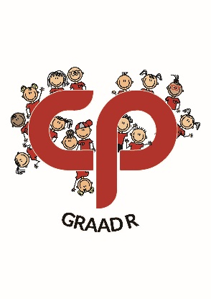**Laerskool Constantiapark**

**Graad R-Pakket**

**2026**

|  |  |
| --- | --- |
| ***Naam van item*** | ***Hoeveelheid*** |
| M&G Houtgom 120ml | 2 |
| M&G Gomstafies 43g | 4 |
| Parrot Witbordmerkers Stel van 4 | 1 |
| Maped Skêr (Linkerhand of Regterhand) | 1 |
| M&G Uitdraaikryte Stel van 12 (klein stelletjie) | 2 |
| M&G Watercolour koki’s | 1 |
| Maped My first JUMBO WAX Colour Peps - 12 | 1 |
| M&G Oliepastelle 12’s | 1 |
| Klein Bordborsel | 1 |
| Croxley Waterverf 12 kleure | 1 |
| Croxley A4 Witbord | 1 |
| Sneesdoekies 100 | 2 |
| Wet wipes | 2 |
| Pakkie Elastoplast pleisters | 1 |
| “My Clear Bag” Meeco Book Bag Rooi | 1 |
| A4 Flipfile 10 pockets rooi kangaroe | 1 |
| A3 Flipfile 20 pockets tooi kangaroe | 1 |
| Klei (Croxley) | 1 |
| Wit roomysbak | 1 |
| Boontjiesak | 1 |
| Swart skooltas | 1 |
| Opsioneel: Swart buitemuurse sportsak | 1 |

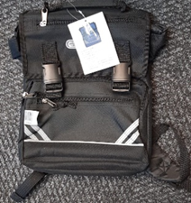Die skooltas kan teen R260-00 by Sinikeza aangekoop word:

(010) 900 1105

info@sinikeza.co.za